Figure 1 The M.D. curriculum program of Prince of Songkla University, Thailand.
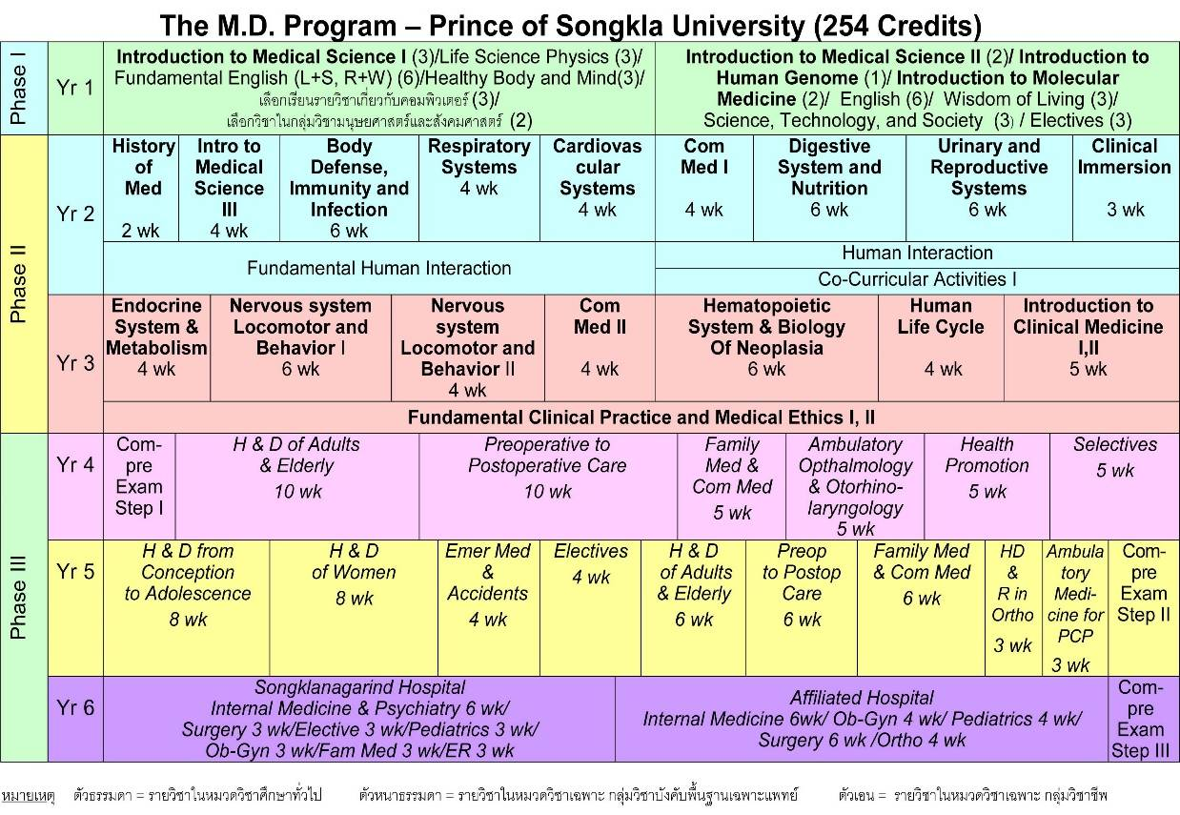

Table 1 Total and subscale PPOS scores according to gender
Score (mean ± SD) | Male | Female | P value
Total PPOS | 3.768 ± 0.42 | 3.856 ± 0.39 | 0.014
Caring | 3.881 ± 0.5 | 3.957 ± 0.42 | 0.028
Sharing | 3.645 ± 0.47 | 3.742 ± 0.48 | 0.005

Figure 2 Boxplot of the PPOS scores according to academic year.
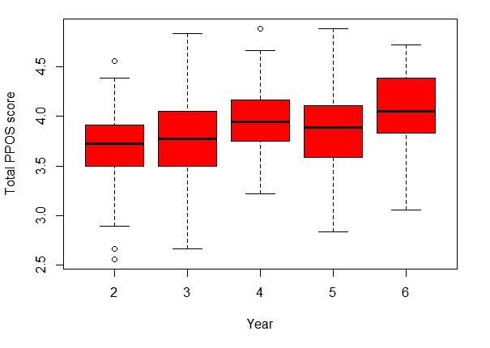

Table 2 PPOS scores according to academic year and gender
Year | PPOS total score(mean ± SD) | Male PPOS score (mean ± SD) | Female PPOS score  (mean ± SD) | P value
2  3  4  5  6  Total | 3.675 ± 0.35  3.79 ± 0.41  3.997 ± 0.34  3.863 ± 0.42  4.079 ± 0.39  3.818 ± 0.41 | 3.642 ± 0.4  3.69 ± 0.37  4.00 ± 0.33  3.835 ± 0.47  4.107 ± 0.39  3.768 ± 0.41 | 3.714 ± 0.31  3.865 ± 0.43  3.995 ± 0.36  3.901 ± 0.35  4.063 ± 0.4  3.856 ± 0.39 | 0.088  0.004  0.878  0.171  0.403  0.014

Table 3 Summary of demographic data and total PPOS score.
Factors | Respondents (%)  N=520 | PPOS total score (mean ± SD) | P value
GPA |  |  | 0.011
≤3.25 | 166 (32) | 3.734 ± 0.39
3.26-3.50 | 128 (25) | 3.844 ± 0.42
≥3.51 | 157 (30) | 3.861 ± 0.42
NA | 69 (13)
Mean expenditure per month (Baht)# |  |  | 0.472
≤6,000 | 243 (47) | 3.776 ± 0.38
6,000-9000 | 170 (32) | 3.849 ± 0.44
≥9000 | 87 (17) | 3.851 ± 0.41
NA | 20 (14)
Hometown |  |  | 0.914
Municipality* | 354 (68) | 3.818 ± 0.4
Non-municipality | 166 (32) | 3.816 ± 0.41
Resident during study period |  |  | 0.677
Dormitory | 409 (79) | 3.821 ± 0.4
House | 86 (16) | 3.787 ± 0.43
Dormitory and house | 25 (5) | 3.86 ± 0.46

Table 4 Multiple regression analysis of PPOS scores by demographic characteristics
Factor | Estimate | SE | P value
Gender  Academic year  GPA  Hometown  Mean expenditure per month  Residence during study period | 0.089  0.090  0.069  -0.003  0.015  -0.007 | 0.038  0.016  0.023  0.043  0.026  0.038 | 0.021*  0.000*  0.003*  0.947  0.566  0.859
Estimate = 3.219; SE_{est} = ±0.125
R = 0.394, R² = 0.1546; P value = 0.000
* Statistically significant.

